Andrew Terbizan:

Navigation map (logical)  
  
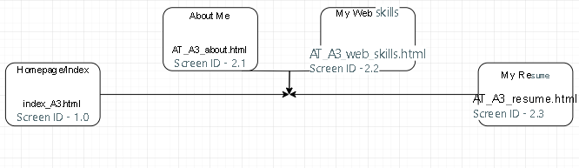

As seen above, all pages connect together through links regardless of which page you’re on out of the above pages as they are linked. E.g. You can get to the homepage from the resume, the resume to web skills etc.